6.22: a) If there is no work done by friction, the final kinetic energy is the work done by the applied force, and solving for the speed,
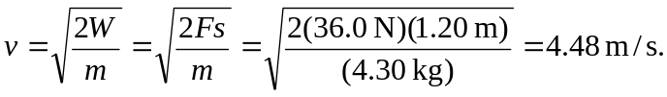
b) The net work is 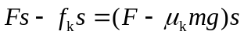, so
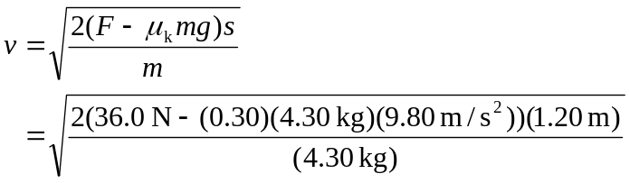
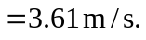
(Note that even though the coefficient of friction is known to only two places, the difference of the forces is still known to three places.)

